Naga City launches Jesse M. Robredo Center for Good Governance (JMR Center)

As a dynamic tribute to the life, works, and accomplishments of the former Mayor and DILG Secretary Jesse M. Robredo, Naga City launched the Jesse M. Robredo Center for Good Governance (JMR Center)! The articulation, exploration, and sharing of the city’s innovative practices in participatory governance will be a major task of the JMR Center. By conducting researches, developing and implementing training and education modules, pursuing issue advocacy, and forging partnerships with other organizations, the JMR Center hopes to contribute to the growing clamor for good governance in the local, national, and international level.

Policy anchors

JMR Center is anchored on at least two(2) executive orders. Executive Order No. 2009-004 entitled “Establishing the Naga City Governance Institute and Defining its Functions and Organization” issued by former Mayor Jesse M. Robredo on the anniversary of the People Power Revolution last 25 February 2009. The NCGI is “created to serve as the single-point agency of the city government that will respond to the challenge of growing, promoting, and sustaining local governance innovations in Naga City and the Bicol Region.”

Incumbent Mayor John G. Bongat also issued Executive Order No. 2013-024 entitled “Renaming the Naga City Governance Institute into the Jesse M. Robredo Center for Good Governance, Redefining Mandates of the NCGI, Reconstituting the Board of Trustees, and Allocating Funds Therefor” last 14 February 2014.

Historic activities
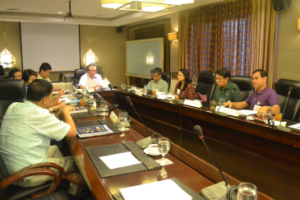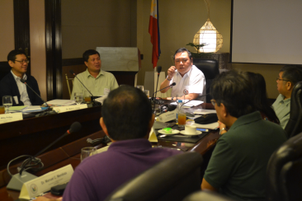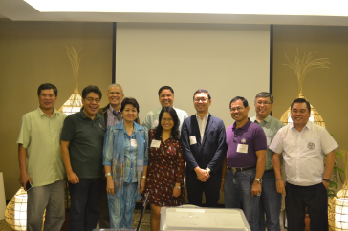

The JMR Center Board of Trustees convened for the first time last 27 February 2014 in Naga City. The following were invited to and attended the said meeting:
(1)Dr. Francisco A. Magno, Director, JMR Institute of Governance, De La Salle University (2)Hon. Gabriel H. Bordado, City Councilor, Chairperson, Committee on People Empowerment, Sangguniang Panlungsod, Naga City (3.)Mr. Willys Prilles, City Planning & Development Officer, Naga City (4.)Marivel C. Sacendoncillo, CESOIII, Executive Director, Local Government Academy (5.)Dr. Maria Ana T. Quimbo (Officially Represented by Dr. Roland Bello), Institute for Governance and Rural Development, College of Public Affairs and Development, UP Los Banos College, Laguna (6.)Dr. Nora L. Licup, Dean, Graduate School, JMR Institute of Local Governance, Bicol University (7.)Ms. Joy Aceron, Ateneo School of Government, Ateneo de manila University, (8.)Dr. Belen Azul (Officially Represented by Dr. Manuel C. Mendoza, Education Supervisor II), OIC Regional Director, CHED RO5 (9.)Hon. John G. Bongat, Mayor, Naga City (10.)Mr. Ram Samar, Chairperson, Naga City Peoples Council (11)Dr. Maria Fe V. Mendoza, Dean, UP-NCPAG, Diliman, Quezon City.

Among the agenda tackled in the meeting are policies on JMR Center mandates, functions, and programs. Most of the Board members dubbed the meeting as “historic” and there was an air of optimism among the group. The prospects of collaboration and joint ventures indeed impacts positively on the persons and institutions engaged in governance.

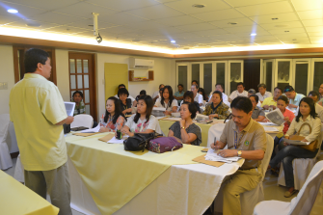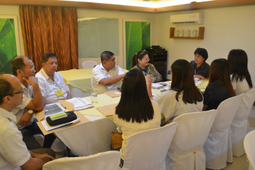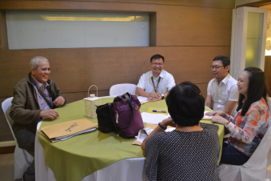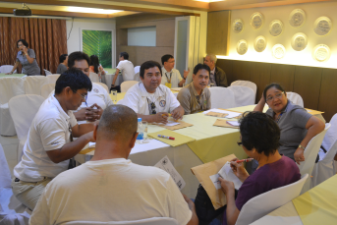

For the first time also, a workshop on the programs of JMR Center was conducted on the same day. Among the participants are present and potential partners of the JMR Center in the locality. Personalities from the academe, LGU officials, business, non-government, and sectoral organizations had initial discussions on the possible programs, projects, activities of the JMR Center in the areas of research, training and education, and advocacy. The result will be part of the inputs for the cluster meetings per program areas. These program clusters will lead the implementation of the JMR Center projects and activities.

Forthcoming activities

As an initial activity for the advocacy program of JMR Center, Hon. Gabriel H. Bordado, City Councilor and Trustee, will lead the first topic in the DISCUSSION SERIES ON CONTEMPORARY ISSUES AND PROBLEMS. Entitled “Electric Power Industry: Issues, Challenges, and Prospects”, the forum will be conducted 8:00am on 19 March 2014 at the Bicol Science and Technology Center, City Hall compound, Naga City.
Details for the following activities are also being worked out: advocacy assemblies, researches and presentations, trainings and module developments.

